

**PROJECT DEVELOPMENT ON**

**MACHINE LEARNING BASED LIVESTOCK HEALTH MONITORING AND MANAGEMENT SYSTEM**

**By**

**AHMED AISHAT ADETUTU**

**20/47CS/01303**

**COURSE CODE: CSC499**

**CHAPTER ONE**

**INTRODUCTION**

* 1. **Background of study**

The global livestock industry is a critical component of agriculture, contributing significantly to food production, rural development, and the global economy. Livestock health directly impacts productivity, food safety, and economic returns. Farmers always facing two main difficulties during the insertion of livestock health data which are consumption of too much time to identify livestock, traditional numbering tags and

the propensity of common mistakes due to human carelessness when inserting data. Traditionally, livestock health monitoring has relied on manual observation and periodic veterinary inspections, which can be time-consuming, labor-intensive, and prone to human error.

Also, traditional means of managing livestock is usually slow when it comes to disease detection within livestock which can be very fatal as this can lead to high death rate or disorder among farm animals. With advancements in technology, particularly in machine learning and the Internet of Things (IoT), there is a growing interest in developing automated systems for livestock health monitoring and management. These systems promise to enhance early disease detection, optimize resource use, and improve overall herd management. Therefore, this research is purposely conducted to overcome those problems by using machine learning technology

* 1. **Problem statement**

The global livestock industry faces significant challenges in maintaining animal health, productivity, and welfare. Traditional methods of livestock management, which rely heavily on manual observation and intervention, are labor-intensive, inconsistent, and often reactive rather than proactive. These methods can result in delayed disease detection, inefficient resource use, and increased operational costs, ultimately impacting the productivity and profitability of livestock operations. However this project tries to eradicate all these problems by making use of machine learning algorithms

* 1. **Aim of study**

**The** main aim of this project is develop a system that can monitor and also predict farm animals (livestock) behavior and also determine and detect diseases earlier in them using various machine learning algorithm E.g K-nearest Neighbor Classifier, K-nearest Neighbor Regression Algorithm . The following are the processes that are taken in this research.

1. Acquisition of livestock dataset which contains various farm animal diseases and the various weather condition that can attribute to this various diseases and symptoms
2. Feature engineering from the acquires dataset that is, picking sub features from the acquires dataset in order for the machine model to be able to make the best prediction and classification where necessary
3. Design and implementation of a web based user interface using Figma as the design tool, HTML, CSS, JAVASCRIPT and DJANGO for the web powering technologies
4. Machine learning model implementation by using K-Nearest Neighbor classifier and K-Nearest Neighbor Regression.
5. Evaluation and Scoring of the prediction value obtained from our model.
   1. **Significance of Study**

Traditionally, monitoring livestock (farm animals) could be very tedious and time consuming has human being are usually prone to errors and mistakes. Also precision is crucial when it comes to anything or field that is related to lives and health. With this, it is known and clear that traditional way of monitoring and taking care of livestock lacks the proper prediction that is needed to manage livestock efficiently and effectively.

A livestock management and monitoring system (LMMS) that leverages modern technology can significantly improve various aspects of animal husbandry. Therefore, the significance of this study to build a system based on machine learning that can be used by livestock managers to take care of livestock on their farmland.

* 1. **Scope of study**

This project covers many aspects and levels of livestock management. The main scope of this research is to develop a method by which it is possible for monitor farm animals without the need to manually to do so. In this study, a machine learning model that leverages the supervised learning algorithm ( like k-nearest neighbor classifier and k-nearest neighbor regression) are used for making prediction and also classification.

**Livestock**

L**ivestock** refers to domesticated animals raised in an agricultural setting to produce commodities such as food, fiber, labor, and other products. These animals are typically managed for economic benefits and are integral to farming and rural economies worldwide. The term "livestock" generally includes a wide range of animal species, each serving various purposes within agricultural systems. Here’s a detailed overview of what constitutes livestock:

**Monitoring System**

A monitoring system is an organized set of tools and processes designed to observe, track, and analyze various parameters or conditions in real-time or at regular intervals. These systems are implemented across different fields to ensure optimal performance, maintain safety, and enhance decision-making through timely and accurate information. Below is an overview of monitoring systems, with a focus on their components, types, applications, and benefits.

* 1. Organization of the project

This project is organized into 5 distinct chapters which explain each step that is taken to achieve the project. Chapter One of this project deals with the introduction to the background study of this project. It also entails a statement of the problems, aim, and objective, the significance of the study, scopes, and the project layout of this research. Chapter Two entails the literature review, review of the related concept, and other typical issues related to the research field of study. Chapter Three covers the analysis of the existing system, a description of the current procedure, the problem of the existing system, and the design of the new system. Chapter Four talks about the system design model, experimentation performed and results analysis are discussed. Chapter Five discussed the strength of the new system, the conclusion, and future work.

**Chapter 2**

**LITERATURE REVIEW**

Below are the literatures that were followed during the process of gathering information about many of the related that have been done earlier on Using Machine Learning For Livestock Management and monitoring system.

1. **IOT - LIVESTOCK MONITORING AND MANAGEMENT SYSTEM Justin Ophir Isaac Dept. Computer Engineering Vidyalankar Polytechnic Mumbai, Maharashtra, India**

The intention of this research is to establish a platform or livestock monitoring and management system. The IOT framework provides IOT solutions in a wide range of domains and applications in farming, livestock, and agricultural front. The technology stack is based on the Internet of Things (IOT) with relevant sensors available to determine the dairy monitoring system to be placed on the animal. This document provides Use Cases (UC) of the domain, and performs evaluations in different conditions which are close to real-time scenarios and operational ones. With the IOT stack, with appropriate sensors for determining geographical boundaries, assets, interoperability, re-usability and functionality, the technical use-case is described in terms of entity/informational model, deployment view, functional view, business process hierarchy. This document provides detailed analysis of the flow of data and its interactions. Proposed Methodology With the introduction of IOT developments in technology space and with appropriate insights, the document captures the required architectural aspects with international standards and provide a high-level view of the system. The use-case pertaining to Livestock monitoring is explained with appropriate entity models, functionality being captured and how the deployment can be done in small, medium and large deployment area. It also highlights the insights of the main endpoints and provides an appropriate gap analysis to this front. From herd management to farm management to people management, challenges are navigated on a daily basis. Proactively detecting and treating diseases in livestock is a challenge. Earlier the trained employees were able to detect the problems at the early stage and provide corrective recourse actions so that the disease is not spread and it is controlled. With Milking Point controllers and Milk Yield Recording parameters, the metadata collected at regular intervals of time and artificial intelligence build, it provides a daily insight on the milk production and health data can be analyzed further. With the technology in place and decision in hand, it would provide a clear insight on the production limits and increase the ROI of investments made. With the insight available, the system would alert for conductivity problems so we can detect diseases in an early stage and take actions which would in turn, avoid losses in terms of milk production or early culling. Milking Point devices facilitate milk harvest of every cow and records operations like Start and End of the milking process, Cleaning, Take off, Pulsation control, Entry/exit gates. The system provides loosely coupled integration to third party applications like Inventory, Dairy management system and other systems which wants to make sense of this metadata. These metadata help to predict in the milking parlor and regulate separation. This also provides actionable insights, saving time and bringing convenience and control.

1. **Machine Learning–Based Predictive Farmland Optimization and Crop Monitoring System Marion Olubunmi Adebiyi, Roseline Oluwaseun Ogundokun , and Aneoghena Amarachi Abokhai.**

The mobile application design for a Machine Learning-Based Predictive Farmland Optimization and Crop Monitoring System integrates advanced analytics to optimize agricultural practices. It utilizes predictive models, IoT devices, and sensors to analyze soil and weather data, providing farmers with insights for optimal planting times, irrigation schedules, and resource usage. The user-friendly interface enables real-time monitoring of crop health, historical data analysis, and actionable recommendations. Security measures ensure data privacy, and the scalable design supports continuous improvement in farmland management. Proposed Methodology The method of classifying and analyzing the results of the classification is divided into phases and functions. The phases include the resource process, which includes the fetching of data from the Crop Info database, which was followed by the generation of machine learning subclasses; the random forest algorithm was used in this phase to create subclasses based on ten different crop feature sets. In the class generation phase, subclasses with similar generation patterns were grouped into three main classes, which are used in the mobile application phase to help optimize the mobile output. The study also used activity diagrams to analyze the system’s behavior and design. This section briefly discussing the interactions between the different activities in the application. It is broken up into three sections: (I) The user login activity. (ii) The scheduler. (iii) Tips and tricks activity 3.3.1. -e Login Activity Diagram. The operation of login as shown in Figure 2 involves a simple user verification process; once user credentials have been submitted, testing will be conducted to decide whether or not the account is valid; when user validity has been verified, the user will have access to the dashboard functions: the key operation, the tips and tricks, and the optimizer. 3.3.2. -e Scheduler Activity. The scheduler activity involves two significant events, as seen in Figure 3. The first one is the schedule event; this task allows users to schedule and display events created by the main task as well as user generated ones. The second event is the reminder event; this activity allows the user to set reminders and to view active reminders created by the main activity and those created by the user. 3.3.3. -e Main Activity. This is the main component of the program, consisting of user input system, machine learning algorithm, feedback system, and database for crop knowledge, as shown in Figure 4. The mobile application allows multiple farm accounts to be opened on the same computer, there are two choices on the start page as shown in Figure 10 to either to create a new farm account as shown in Figure 11 or open an existing farm account as seen in Figure 12. The user has access to the dashboard after successful login or sign-up, as shown in Figure 13, and its functions. The functions of the dashboard are the optimizer function, as seen in Figure 14, which is the main application operation; the scheduler function; and the tips and trick’s function which contains the knowledge repository. The optimizers consist of three fields of data: the field of farm size input that takes numerical input in square meters, the area field that takes user location input, and the field of pH input that takes the farm soil input as seen in Figure 15. Users choose the crops they want to grow on their farm, and the outputs are displayed in the optimizer output area based on the input as in Figure 16. The scheduler as seen in Figure 17 enables users to set the events or activities that they wish to perform. The user shall provide the task mark and pick the date of the work to be performed.

1. **On-farm welfare monitoring system for goats based on Internet of Things and machine learning. Yuan Rao1,2,3 , Min Jiang1,2, Wen Wang1,2,WuZhang1,2 and Ruchuan Wang3**

Intensive animal husbandry is becoming more and more popular with the adoption of modern livestock farming technologies. In such circumstances, it is required that the welfare of animals be continuously monitored in a real-time way. To this end, this study describes one on-farm welfare monitoring system for goats, with a combination of Internet of Things and machine learning. First, the system was designed for uninterruptedly monitoring goat growth in a multifaceted and multilevel manner, by means of collecting on-farm videos and representative environmental data. Second, the monitoring hardware and software systems were presented in detail, aiming at supporting remote operation and maintenance, and convenience for further development. Third, several key approaches were put forward, including goat behavior analysis, anomaly data detection, and processing based on machine learning. Through practical deployment in the real situation, it was demonstrated that the developed system performed well and had good potential for offering real-time monitoring service for goats’ welfare, with the help of accurate environmental data and analysis of goat behavior. Proposed Methodology By following this proposed methodology, you can develop and implement an effective On-farm Welfare Monitoring System for goats, combining the benefits of IoT and machine learning to enhance animal welfare and farm management: 1. Literature Review: Objective: Understand existing research and technologies related to on-farm welfare monitoring systems, IoT applications in agriculture, and machine learning for animal health. Activities: Review relevant scientific papers, articles, and existing on-farm monitoring systems. Identify successful case studies and technological advancements. 2. Requirements Analysis: Objective: Define the specific requirements and objectives of the on-farm welfare monitoring system for goats. Activities: Consult with veterinarians, goat farmers, and experts in animal science. Identify key welfare indicators to monitor (e.g., health status, activity levels, feeding patterns). 3. User Interface Design: Objective: Create a user-friendly interface for farmers and veterinarians to monitor the welfare of goats. Activities: Design dashboards displaying real-time and historical data. Implement alerts and notifications for abnormal conditions 4. Machine Learning Model Development: Objective: Develop machine learning models to analyze sensor data and assess the welfare of goats. Activities: Collect labeled training data for supervised learning. Develop models for health prediction, anomaly detection, and behavior analysis. 5. Integration of IoT and Machine Learning: Objective: Integrate the IoT devices with the developed machine learning models. Activities: Develop an interface that allows real-time data flow from sensors to the machine learning algorithms. Implement a feedback loop for continuous improvement of the models.

1. **An application oriented IoT based real-time livestock management system using machine learning technology in secure manner. Salman Us Sakib1, MD. Uthba Bin Anowar Binoy1,Sweet Rana1,Rashed Mazumder1**

The livestock monitoring and prediction system is composed of several components. To begin, a multi-sensory device should be developed to collect all of the required physiological data from farm animals. The sensing device will be minimally processed and networked. Such IoT solutions will provide all of the data necessary for the back-end application to function correctly. Hence, the second component of the system is an edge cloud storage solution for securely communicating and storing data. The edge-cloud computing architecture redistributes processing power, resulting in faster computing. Moreover, AES based encryption is used at the network’s edge to prevent intrusion. A software defined network (SDN) for validating the packets sent by the edge device can significantly improve security. The cloud system contained the necessary decryption procedures to convert the data to a suitable format. Following that, the third component of the system consists of both traditional deterministic and machine learning related probabilistic algorithms, as well as pre-processing of the IoT system’s collected data. Proposed Methodology The livestock monitoring and prediction system is separated into several parts. First, a multi-sensory device has to be developed in order to collect all the necessary physiological aspects of farm animals. These aspects include but are not limited to body temperature, heart rate variability, sudden movement and acceleration, food consumption, respiration rate, rumination, heartbeat, heat stress, blood pressure, physical gesture, humidity, which are embedded in a single device like system. This device will be implemented with minor processing and networking capabilities. External factors such as location tracking, herd management, gazing time for accurate livestock monitoring will be implemented in separate devices and will work as a part of the farming system. The devices mentioned above will connect to the cloud with supported protocols like MQTT, TCP/IP, and CoAP. These IoT solutions will provide all the necessary information required for the back-end application to be operational. Figure 4 delineate the message passing sequence diagram of proposed system. Thus, Fig. 2. Use cases for The Proposed Livestock Monitoring and Prediction System. the second part of the system consists of a cloud storage solution for storing the data securely. As the sensors are coupled with a microprocessor or micro-controller with limited computational power, some pre-processing will reduce the work load at the server end. AES and other layer wise security measures will be taken to ensure security [17]. This cloud-edge computing scheme will redistribute the total amount of processing resulting in faster computing. After that, the third part of the system comprises both traditional deterministic and ML related probabilistic algorithms with pre-processing of the collected data by the IoT system. Figure 1 describe the activity diagram of proposed system. The deterministic algorithm will be utilized to calculate definitive decisions like time of vaccination, number of animals in one cattle, cattle management, the energy efficiency of the firm, and many more. ML algorithms will be involved in monitoring and predicting strategies like health conditions, meat production, milk production, pregnancy prediction, etc. To predict from the numerical pre-processed data, ML classifiers like SVM, RF, ANN will be utilized. For the prediction from historical data, time series analysis deep learning algorithms such as RNN, LSTM will be utilized. However, it should be mentioned that the most appropriate and accurate algorithm will be implemented in the final application among the algorithms. For the last part of the LMS system, both mobile and web platform applications will be developed for friendly user- interaction and usability.

1. **Automated Tele-Health Monitoring and Life Prediction of Structures. Ravichandra. B, Lakshmi Narayana Reddy. B, B. Keerthi Priya, D. Akhila Reddy, A. Daisy Rani.**

For effective livestock management identification and control of parasites and bacteria is a challenging factor. Parasites, worms and bacteria has a huge hazard to the health of animals, which can harm the gastrointestinal tract, and result in decreased propagative routine, diminished development rates, less yield in terms of meat, fiber and milk, even leads to death of the animals, which in turn causing health problems for human society also. A proper knowledge of animal parasites by identification of them and application of the proper antibiotic or vaccine in appropriate dosage will improve the quality of the livestock and its byproducts leading to the more profits to the farmer. The livestock farms are located at the remote places and the communication between the veterinary doctor to the farmer is poor, took long time and expensive. This can be overcome by utilization of the digital technology and automation of the process which can be handled by a layman at the field to provide electronic information for both e-prescription for intermediate treatment and the information to the expert at the remote location for proper diagnosis and validation of the electronic prescription. Digital image processing of the microscopic pictures with high resolution cameras from the samples of the animals will provide a platform for automation of the process. The detection of the parasites and its stages can be done by denoising the images, segmentation of the parasites, templating the images for isolation of parasites and bacteria by comparing them with preloaded data of different types of parasites and their different stages leads to the identification of parasites, bacteria and giving the electronic prescription within a short period then the diagnosed report can be sent to the expert for validation. In the present paper the authors have proposed a smart system for tele-monitoring and mobile health management system. Proposed Methodology The proposed automated method is developed by the process as appeared in the flowchart fig.3. In the first stage, the samples are collected from the animals. From the collected samples the images will be acquired by using high resolution microscopes. In the second stage these collected images should undergo various images pre-processing tasks such as image-enhancement, image-denoising etc., In the final stage the identification of types of parasites exists in the sample and type of diseases are done by using image-segmentation and object/matter identification etc., The diagnostic report will be directed to the expert for validation purpose. At the end, the entire process is linked up with mobile-application for user friendly operation of dairy farmers.

1. **Challenges to Use Machine Learning in Agricultural Big Data: A Systematic Literature Review. Craverio Ania, Pardo Sebastian, Sepulveda Samuel, Munoz Lilia**

Agricultural Big Data is a set of technologies that allows responding to the challenges of the new data era. In conjunction with machine learning, farmers can use data to address problems such as farmers’ decision making, water management, soil management, crop management, and livestock management. Crop management includes yield prediction, disease detection, weed detection, crop quality, and species recognition. On the other hand, livestock management considers animal welfare and livestock production. The purpose of this paper is to synthesize the evidence regarding the challenges involved in implementing machine learning in agricultural Big Data. We conducted a systematic literature review applying the PRISMA protocol. This review includes 30 papers published from 2015 to 2020. We develop a framework that summarizes the main challenges encountered, machine learning techniques, and the leading technologies used. A significant challenge is the design of agricultural Big Data architectures due to the need to modify the set of technologies adapting the machine learning techniques as the volume of data increases. Proposed Methodology The research method used for this paper was SLR. For the selection of articles, the PRISMA (Preferred Reporting Items for Systematic Reviews and Meta-Analysis) method was applied, which contains four stages: identification, screening, eligibility, and inclusion [12]. To define the objectives and research questions (RQ), we used the methodology proposed by Kitchenham and Charters [34]. The analysis stems from a series of RQ such as (1) what kind of problems are solved using agricultural Big Data and ML, (2) what is the agricultural line of business in which the problems are attempted to be solved, (3) what are the main ML techniques used to analyze the data, (4) what technological tools are used to implement agricultural Big Data, and (5) what are the challenges to implement ML in agricultural Big Data.

1. **Auto-Encoder Learning-Based UAV Communications for Livestock Management: Mohammed A. Alanezi 1, Abdullahi Mohammad 2,3 , Yusuf A. Sha’aban 2,4 , Houssem R. E. H. Bouchekara 4,* and Mohammad S. Shahriar 4 •**

Built an auto-encoder for end-to-end wireless communications for UAV-assisted livestock management systems. We showed that learning the entire transmitter (UAV) and receiver (GCS or UAV) implementations for a given communication channel link optimized for a chosen loss function (e.g., minimizing BER) is possible. The basic idea is to describe the transmitter, channel, and receiver as a single deep CNN that can be trained as an auto-encoder. Interestingly, this technique can be used as a model approximator to approximate optimal solutions for systems with unknown channel models and loss functions. • We simulated the communication links with a different set of communication rates to learn various communication schemes, such as QPSK, 8PSK and 16QAM. For a (7, 4) communication rate, the proposed auto-encoder performance matched the optimal Hamming code maximum likelihood decoding scheme. Proposed Methodology Generally, a simple communications system can be viewed as a particular type of autoencoder from the deep learning viewpoint [30,33]. An auto-encoder is an unsupervised learning model that learns to squeeze and reconstruct the input. Therefore, it can be considered a dimensionality reduction framework that allows the input reconstruction at the output with minimal error. However, in our case, the auto-encoder is used for end-to-end communication to learn the representations of the messages s that are robust to the channel impairments mapping x to y, such that the transmitted information can be recovered with a minimal probability of error. Contrary to redundancy removal from the input data for compression, our proposed auto-encoder usually adds redundancy, learning an intermediate representation robust to channel variations for reliable data transfer. Firstly, the UAV flies above the livestock to capture data (usually real-time images) about the livestock and send it to the GCS for analysis. The reliable data transfer requires that the UAV communication system be divided into a sequence of communication blocks, which are traditionally optimized individually. Such an approach depends on complex mathematical models that are usually intractable. However, the communication blocks are jointly optimized as a single learning block to simplify the process while ensuring reliable data transfer from the UAVs to the GCS.

**Chapter 3**

**RESEARCH METHODOLOGY**

**3.1 Data Acquisition:**

The dataset was acquired from an open source website that specializes in machine learning and also the collection of datasets around the world. This datasets can be real life dataset or synthetic (scientifically generated) datasets. The dataset that was acquired for this project is a real life dataset that consists of various farm animals alongside their various age, temperature, and symptoms and the corresponding diseases. The livestock( farm animals) that exist in this dataset includes, Goats, Sheep, Buffaloes, cows and many more livestock which are majorly domestic animals.

Each of the farm animals have its own age and the corresponding temperature with 3 more symptoms that is used to determine if the farm animal in question is having a particular disease or not

Also data are acquired from various sensors that is placed on the farm animals which is used in the prediction and health classification stage of the machine learning model.

All these acquired data are being stored in an excel sheet. This is used because of the high features that comes with using excel sheet for data storage

Table 3. 1 A detailed list of dataset features and all possible values is shown

**Dataset for Livestock Diseases**

|  |  |
| --- | --- |
| **Feature** | **value** |
| Animal | Cow, Buffalo, Sheep , Goat |
| Age | 3, 4 , 9 , 7 , 10 , 6 , 1 , 2 , 8 , 5 ,12  14 ,15 ,13 ,11 |
| Temperature | 100.0 - 105.0 |
| Symptoms 1 | 'loss of appetite', 'depression', 'painless lumps',  'difficulty walking', 'lameness', 'crackling sound',  'shortness of breath', 'fatigue', 'chest discomfort', 'sweats',  'chills', 'swelling in muscle', 'swelling in limb',  'swelling in extremities', 'swelling in neck', 'swelling in abdomen',  'blisters on tongue', 'blisters on hooves', 'sores on tongue',  'sores on gums', 'blisters on mouth', 'sores on mouth',  'blisters on gums', 'sores on hooves' |
| Symptoms 2 | loss of appetite', 'depression', 'painless lumps',  'difficulty walking', 'lameness', 'crackling sound', 'chills', 'sweats',  'shortness of breath', 'chest discomfort', 'fatigue',  'swelling in muscle', 'swelling in limb', 'swelling in abdomen',  'swelling in extremities', 'swelling in neck', 'sores on tongue',  'sores on hooves', 'blisters on gums', 'blisters on hooves',  'sores on gums', 'blisters on tongue', 'sores on mouth',  'blisters on mouth' |
| Symptoms 3 | loss of appetite', 'depression', 'painless lumps',  'difficulty walking', 'lameness', 'crackling sound', 'fatigue',  'sweats', 'shortness of breath', 'chest discomfort', 'chills',  'swelling in muscle', 'swelling in limb', 'swelling in abdomen',  'swelling in extremities', 'swelling in neck', 'sores on gums',  'sores on mouth', 'sores on hooves', 'sores on tongue',  'blisters on hooves', 'blisters on mouth', 'blisters on gums',  'blisters on tongue' |
| Disease | 'anthrax', 'blackleg', 'foot and mouth', 'pneumonia', 'lumpy virus' |

**Dataset for Livestock Health classification**

|  |  |
| --- | --- |
| AnimalName | 'Dog' 'cat' 'Rabbit' 'cow' 'chicken' 'cattle' 'mammal' 'Cattle' 'Horse'  'Turtle' 'Hamster' 'Lion' 'Fox' 'Fox ' 'Goat' 'Deer' 'Chicken' 'Monkey'  'Birds' 'Sheep' 'Pigs' 'Fowl' 'Duck' 'Other Birds' 'snake' 'horse' 'duck'  'donkey' 'Donkey' 'mules' 'Elephant' 'Elk' 'Wapiti' 'Mule deer'  'Black-tailed deer' 'Sika deer' 'White-tailed deer' 'Reindeer' 'Moos'  'Tiger' 'Goats' 'Buffaloes' 'Dogs' 'Wolves' 'Hyaenas' 'Pig' |
| Symptoms1 - Symptoms5 | 'Fever' 'Ulcers' 'Facial Swelling' 'Swelling on leg'  'Short term lethargy' 'Swollen lymph nodes' 'Diarrhea with muscus' , 'Fever' 'Ulcers' 'Facial Swelling' 'Swelling on leg'  'Short term lethargy' 'Swollen lymph nodes' 'Diarrhea with muscus'  'Strong cough' 'Lesions in the nasal cavity'  'Strong cough' 'Lesions in the nasal cavity' 'Hair loss', e.t.c |
| Dangerous | Yes, No |

#### 3.2 Data Analysis

#### The data analysis stage is the stage where all the data that was collected from several sources are being analyzed and cleaned in order for them to be able to fed into the machine learning model. This phase is very crucial as any inappropriate data that is fed into the machine learning model will result in lesser and sometimes bad efficiency of the entire system.

#### The data analysis phase contains the following stages for the proper cleaning and preparation of the data:

* **Data Preprocessing**:

In the data processing stage, the collected raw data from various sensors and devices is prepared and refined for further analysis. This begins with data cleaning, where any errors, inconsistencies, or missing values in the dataset are identified and corrected. The goal is to ensure the integrity and quality of the data, which might involve techniques like imputation to fill in missing values, or removing outliers that could skew the results.

Once the data is cleaned, preprocessing steps are taken to standardize and normalize the data. Standardization involves transforming data to have a mean of zero and a standard deviation of one, which is crucial for algorithms that assume normally distributed data. Normalization scales the data to a specific range, often between 0 and 1, ensuring that all variables contribute equally to the analysis, regardless of their original scale.

After preprocessing, the data is transformed into formats suitable for analysis. This might include aggregating data over specific time periods, converting categorical data into numerical values through techniques like one-hot encoding, and creating new features that better capture the underlying patterns in the data.

* **Statistical Analysis:**

In the statistical analysis stage, the goal is to extract meaningful insights and patterns from the processed data. This begins with descriptive statistics, which provide a summary of the data's main characteristics. Measures such as mean, median, mode, standard deviation, and variance are calculated to understand the central tendency and dispersion of the data. These statistics help to get an overview of the data and identify any initial patterns or anomalies.

Visualization is a crucial part of this stage, as it allows for the graphical representation of data through charts, graphs, and plots. Techniques like histograms, bar charts, scatter plots, and box plots are used to visually inspect the data, making it easier to spot trends, outliers, and relationships between variables.

* **Machine Learning**

In the machine learning stage, the objective is to develop predictive models that can analyze the processed data and provide insights or forecasts about animal health. This stage begins with selecting and preparing the data for modeling. This involves splitting the dataset into training and testing sets. The training set is used to train the machine learning models, while the testing set is used to evaluate their performance. This ensures that the models can generalize well to unseen data. The machine learning program which is written in python runs at the backend off the software in which case, data is passed from the Frontend to the backend program and the desired output which is to determine if the animal is healthy or not is given back as output.

**3.3 Animal disease prediction and classification:**

Prediction and classification is the step taken to classify and mark a specific livestock as being healthy or not.

Classification is the process of placing a particular livestock in a class. The algorithm that is used in making this classification is the Logistics Regression algorithm that is written in python. Also some classifications are also made with Naïve Baiyes Algorithm.

**LINEAR LOGISTICS ALGORITHM:**

Linear logistic regression, often referred to simply as logistic regression, is a statistical model used for binary classification tasks. It's a supervised learning algorithm where the target variable (dependent variable) is categorical. Unlike linear regression, which predicts continuous values, logistic regression predicts the probability of the input belonging to a particular class, typically represented as 0 or 1.

### Key Concepts:

1. **Logistic Function (Sigmoid Function):**

Logistic regression uses the logistic function, also known as the sigmoid function, to model the relationship between the independent variables and the probability of the output. The sigmoid function is defined as:

σ(z)=11+e−z\sigma(z) = \frac{1}{1 + e^{-z}}σ(z)=1+e−z1​

where z=β0+β1x1+β2x2+…+βnxnz = \beta_0 + \beta_1 x_1 + \beta_2 x_2 + \ldots + \beta_n x_nz=β0​+β1​x1​+β2​x2​+…+βn​xn​

is the linear combination of the input features x1,x2,…,xnx_1, x_2, \ldots, x_nx1​,x2​,…,xn​ weighted by coefficients β1,β2,…,βn\beta_1, \beta_2, \ldots, \beta_nβ1​,β2​,…,βn​.

1. **Model Interpretation:**
   * The output of the logistic regression model, p^=P(y=1∣x)\hat{p} = P(y = 1 \mid x)p^​=P(y=1∣x), gives the probability of the input xxx belonging to class 1.
   * The probability of the input belonging to class 0 is P(y=0∣x)=1−p^P(y = 0 \mid x) = 1 - \hat{p}P(y=0∣x)=1−p^​.
   * The decision boundary is typically set at p^=0.5\hat{p} = 0.5p^​=0.5.

**NAÏVE BAYES ALGORITHM:**

Naive Bayes is a popular probabilistic machine learning model based on Bayes' theorem, with an assumption of independence between the features. Despite its simplicity and the "naive" assumption, it performs surprisingly well in many real-world applications, especially in text classification and spam filtering.

# Explanation of the Naïve Bayes Algorithm

The Naïve Bayes algorithm is explained below

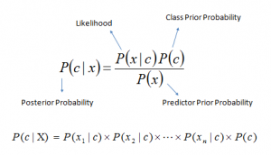

Where p(c) is the probability of ………………………………..

The algorithm calculates posterior probabilities to make predictions based on conditional probabilities. It simplifies computation by considering features independently, even if they are interdependent, hence the term "naïve." Naïve Bayes classifiers are part of generative learning algorithms, modeling the distribution of inputs of a given class or category

**3.4 Hardware And Software Requirement**

The hardware and the software that is required to run or power this task effectively includes:

Hardware Requirement:

The hardware requirement refers to the tangible (physical) component to be used for the development of the system and these are; Personal computer (PC) which include MacBook, Hp, Dell e.t.c with at least memory size of 4G RAM and 256G hard drive with a core i3 processor or higher. Those are the minimum hardware requirement for any computer to run this algorithm and model.

Software Requirement:

Windows 8 or higher operating system software can be used for the deployment of this system or a MacBook Air or higher. Terminal or Command Prompt, Cross-platform(X), Apache (A), and Python3 will all be used in the project to develop the system. Visual Studio Code is the software package that will be used to create the source file to make the system run on the terminal. Also Pycharm which is a powerful IDE for writing and executing python codes is also used for the development of this project.

The various libraries and packages includes:

Sklearn -(scikit-learn), Pandas, Numpy e.t.c

**CHAPTER 4**

**IMPLEMENTATION**

**4.0 Synopsis**

Implementation is the phase of the project where the hypothetical outline is transformed into a occupied system. It is basically related with user activity or interaction and documentation. Change always happens about the exact time the user is consistently prepared or later. Execution can be mostly means sorting out other system plan into operation, which is the methodology of shifting another reviewed system outline into an operational process. This phase typically involves the model training using the acquiered dataset of various farm animal diseases, and also the the user interface integration and implementation which invloves the Front end and back end interface of the application

**4.1 Choice of Programming Languages**

The proposed system is written with various web programming languages as well as python programming language which is used to implement the machine learning aspect of the program.

The programming languages that are used in the course of developing the application includes:

**4.1.1 Python**

Python is a high-level, interpreted programming language known for its simplicity and readability. Its syntax is designed to be easy to understand, which makes it an excellent choice for beginners and allows developers to write clear and concise code. Python supports multiple programming paradigms, including procedural, object-oriented, and functional programming. It has a vast standard library that provides tools suited to many tasks, from web development and data analysis to artificial intelligence and scientific computing. The language's dynamic typing and automatic memory management facilitate rapid development, while an active and supportive community contributes to an extensive ecosystem of third-party packages and frameworks.

**4.1.2 HTML**

The regular content positioning dialect forreports on the interrelated registering system known as the World Wide Web. HTML reports are gratified documents that contain two sections: method that is intended to be rendered on a machine monitor; and markup or labels and tag, encoded data that runs the gratified organization on the screen and is for the most part avoided the client to make utilization of the tag. A few labels in a HTML file focus the way positive content, for example, titles will be designed. The improvement of a Hyper Text Markup Language (HTML) and the addition of a Hyper Text Transmission Protocol (HTTP), and shaping World Wide Web in right on time 1990s Terje (2005).This means that since it is possible to access the data on the network, then HTML was used to design the web pages.

**4.1.3 CSS**

CSS, or Cascading Style Sheets, is a stylesheet language used to control the presentation of web pages. It allows developers to separate content from design by defining styles for HTML elements, such as layout, colors, fonts, and spacing. CSS enhances the visual appeal and user experience of a website by enabling responsive design, which adapts to different screen sizes and devices. It works by applying rules through selectors, properties, and values, which can be targeted to specific elements, classes, or IDs within the HTML. With CSS, you can create consistent and visually appealing web pages while maintaining flexibility and ease of maintenance. It also supports advanced features like animations, transitions, and grid systems, enabling complex and dynamic layouts.

**4.2 System Main Implementation**

The system is organized into Front end and Back End side. The front end part of our proposed system is responsible for the rendering and management of the user interface which is maintains and oversees how the program is being displayed and how the user who will be making use of the application will interact with our application.

**4.2.1 Front End**

The implementation starts with HTML, the backbone of web content, structuring the web pages by defining elements like headings, paragraphs, forms, and buttons. CSS is then applied to style these elements, ensuring they look visually appealing and consistent across different browsers and devices. CSS frameworks and preprocessors like Bootstrap, Sass, and LESS can enhance and streamline the styling process.

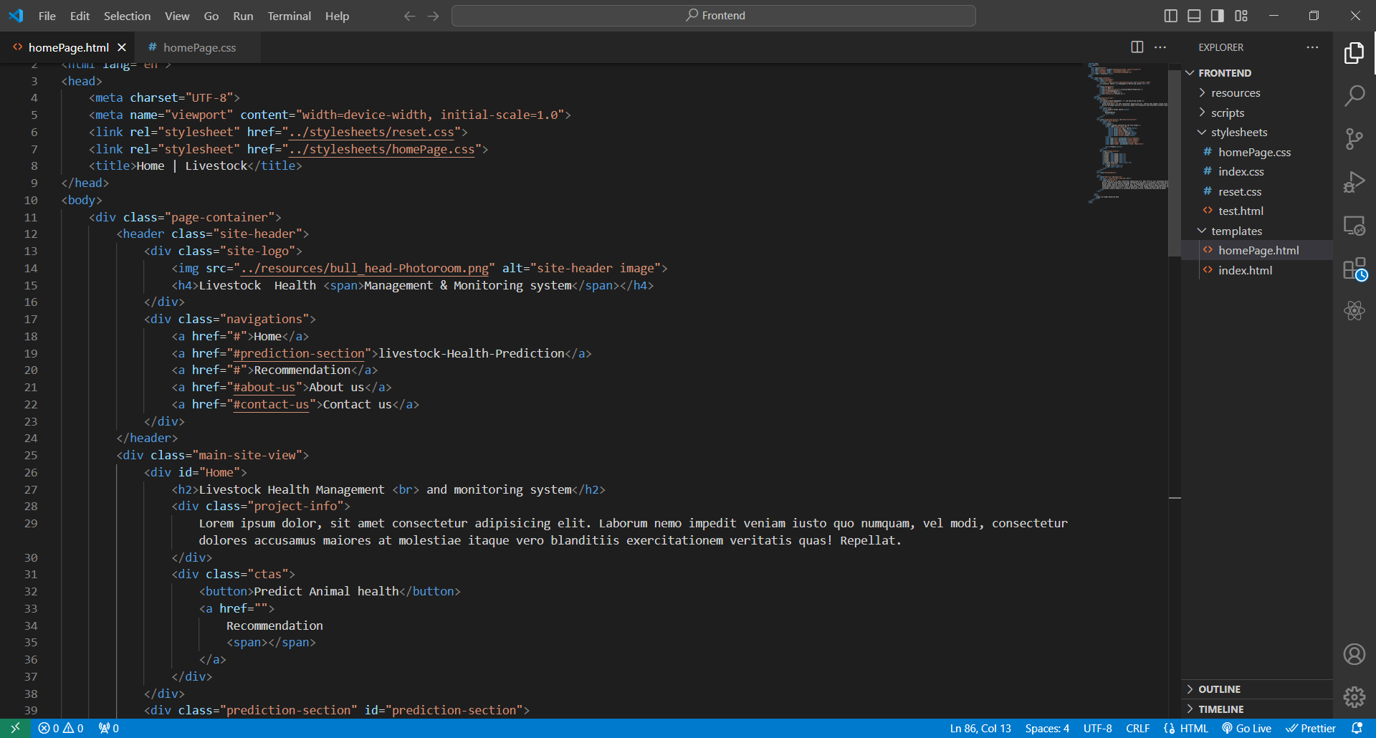

**Fig 4.2.1 An HTML showing the markup part of the proposed system**

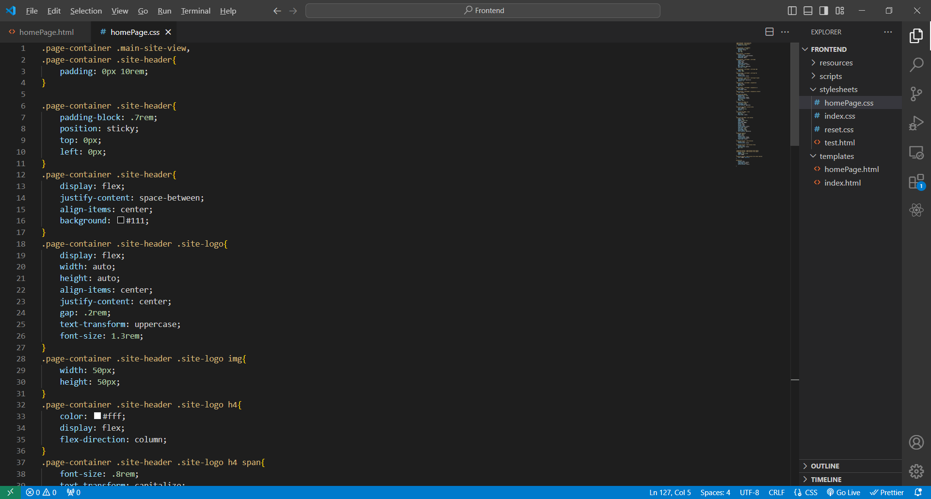

**Fig 4.2.2 A CSS page showing the styling of the proposed system**

With the combination of this two web technologies, the user interface is being built and constructed and then rendered to the user. The interface allows users to enter three(3) farm animal symptoms, the age, and then the temperature of the farm livestock under study. This data is then sent to the back end program which is running locally on our local server that is powered by Django. This data which is sent is then used to make predictions about the disease which the farm animal is having.

Below is the image which shows the interface which is used to accept data from users.

**4.2.2 Back End**

The back end side of our proposed system is the main engine which powers and run the application. It involves the program which makes prediction, the template (user interface ) rendering engine, and also URL routing.

**Prediction Model:**

This model is a machine learning model which is trained with farm livestocks disease dataset. The model is implemented in python and also uses various python libraries which includes:

* Sklearn
* Numpy
* Pandas
* Matplotlib
* And the Math module

**Model Training and Evaluation:**

The model training and evaluation phase involves various stages which are :

- Dataset Loading: this is the stage in which the datase which is used to train our model is being loaded in the program

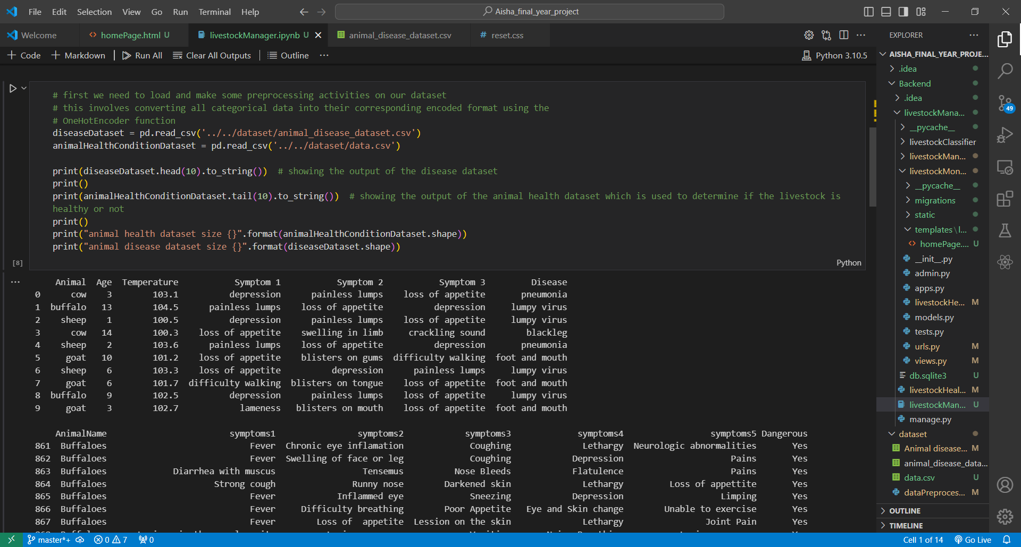

Fig 4.1 Dataset loading

- Data preprocessing: this is the phase in which the loaded dataset is being preprocessed and cleaned in order to get rid of any inconsistency and noise in the data

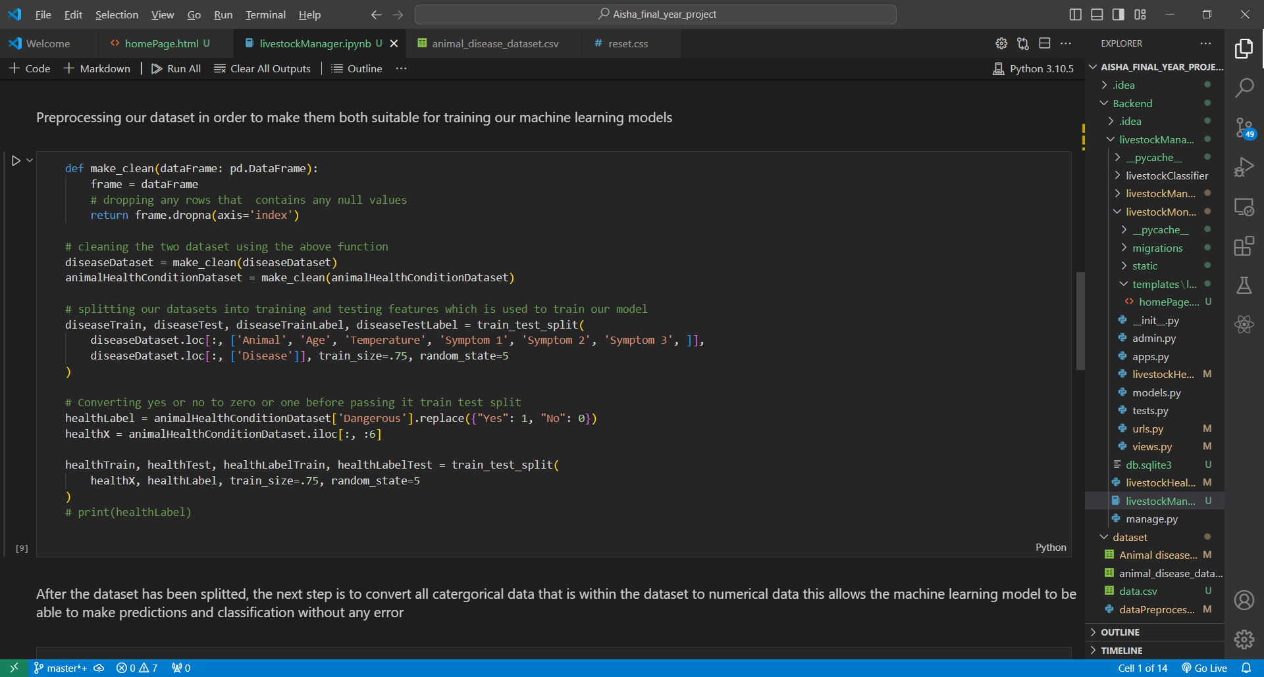

Fig 4.2 Dataset Preprocessing

- model Training: This is the phase in which the model is being trained with the available dataset

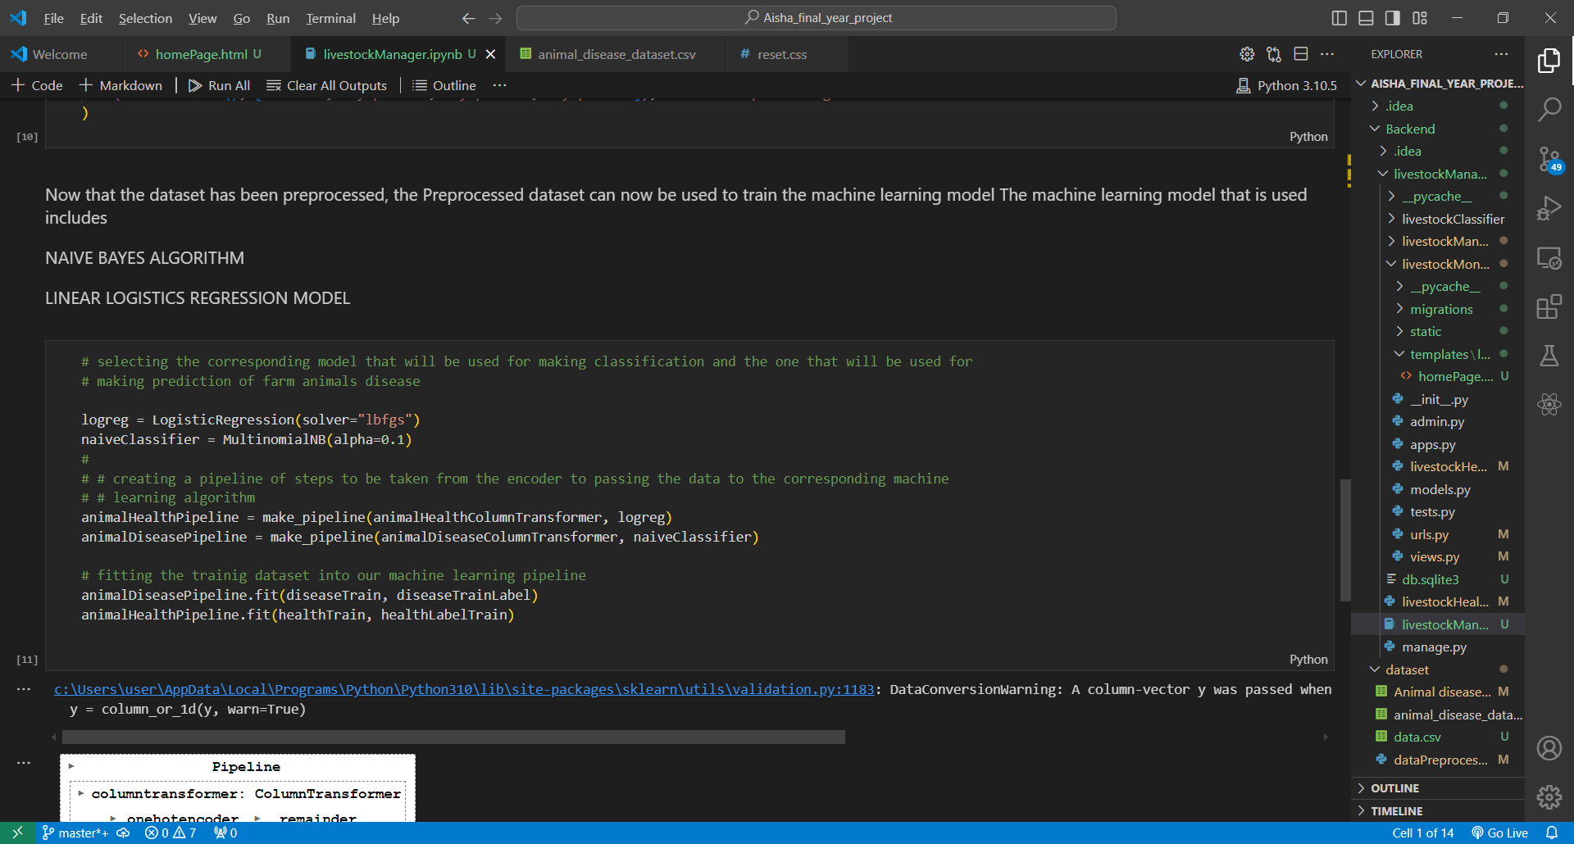

Fig 4.3 model training

- Model Evaluation: This is the phase in which the model is being tested and evaluated to see how well the model will perform on the test dataset and also the training dataset

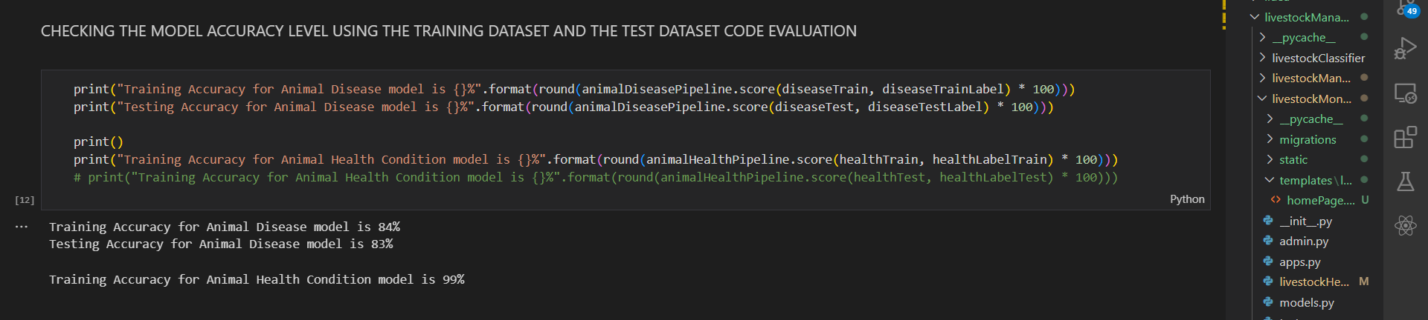

Fig 4.4 Model Evaluation and Testing

**URL routing and Template Rendering;**

This part of the program handles the viewing and the rendering of the user interface program and the handling of the user submitted data which is used to make predictions in real time.

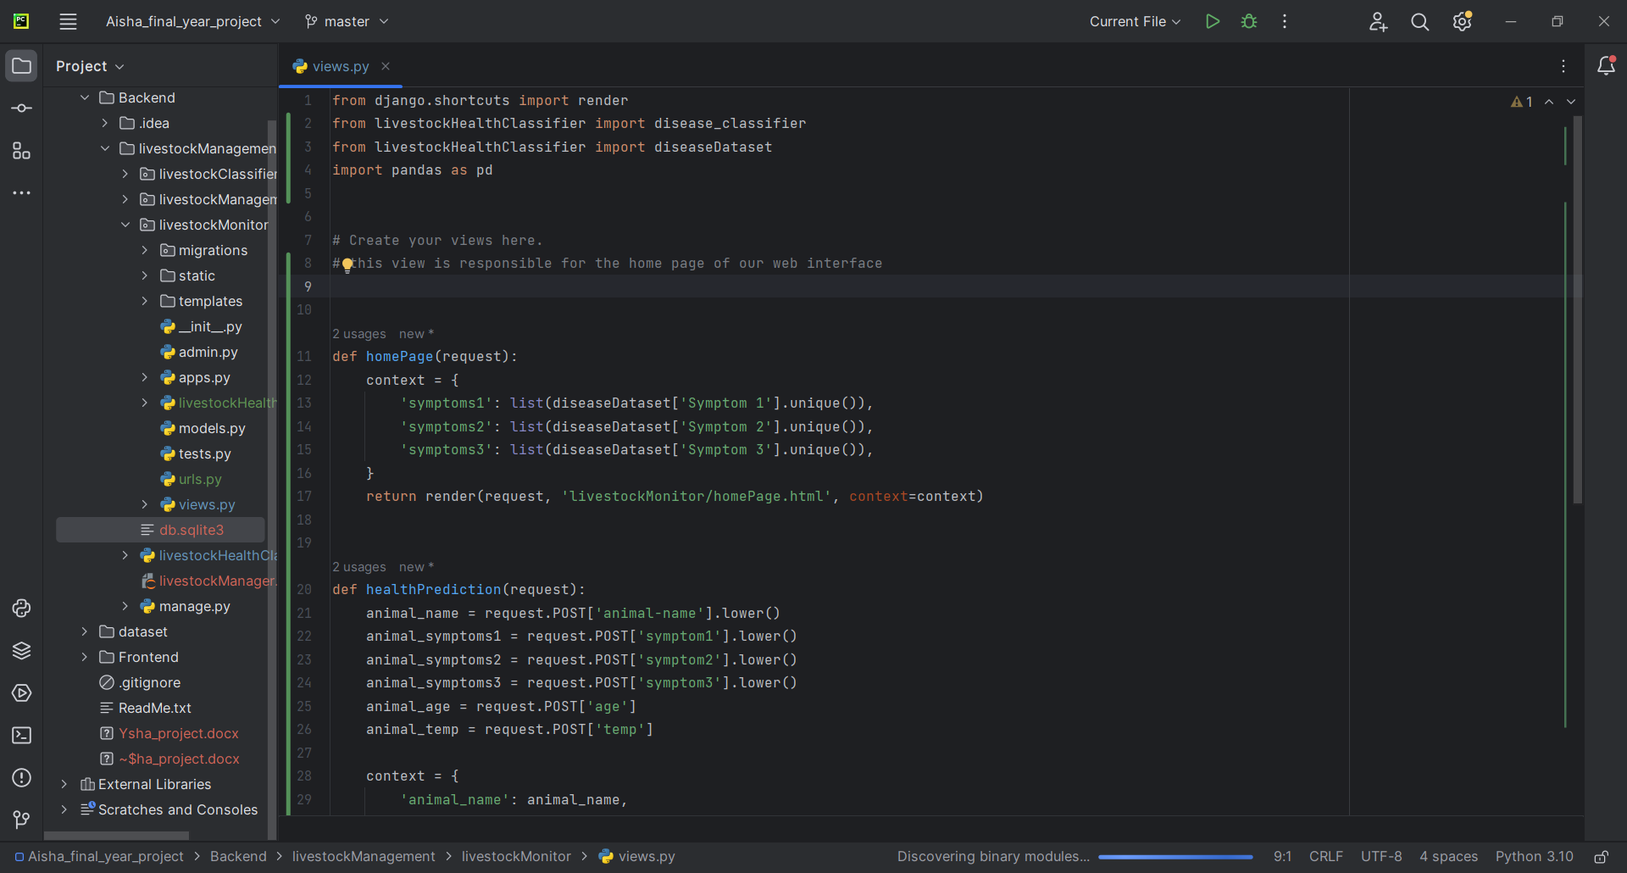

Fig 4.5 the rendering of user interface program and also the handling of user submitted data

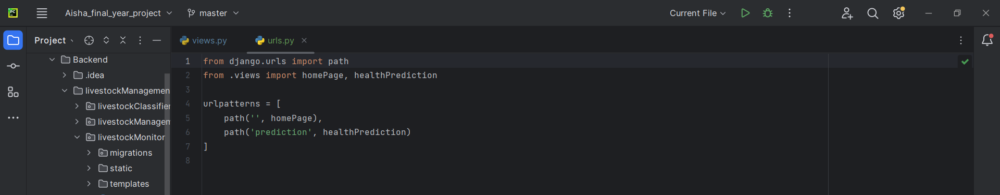

Fig 4.6 URL routing and handling.

**4.4 System Testing**

This phase begins with splitting the data into training and testing sets, ensuring that the model is assessed on unseen data to simulate real-world scenarios. Various metrics, such as accuracy, precision, recall, and F1 score, are used to quantify the model's effectiveness. Cross-validation techniques may be employed to ensure robustness by repeatedly training and testing on different subsets of the data. During this phase, it is crucial to check for overfitting and underfitting, adjusting hyperparameters and refining the model as necessary. The results are often visualized using confusion matrices, ROC curves, or precision-recall curves to gain insights into the model's behavior. Additionally, the model is subjected to stress tests using edge cases and rare scenarios to ensure its reliability and stability. This comprehensive evaluation helps in understanding the model's strengths and limitations, guiding further improvements or confirming its readiness for deployment.

**Chapter 5**

**SUMMARY, CONCLUSION AND RECOMMENDATION**

**5.1 Summary**

In the existing system, livestock Monitoring were operating merely manually. A livestock health management and Monitoring System is an innovation or invention approach to improve the service of Monitoring livestocks in addition to existing means. In an extreme exposure, during the investigation work of this project, I was able to realize that the unfailing problem encountered is as a result of improper farm animal data handling and management approach which includes lack or proper farm animal maintenance and monitoring. Essentially, the various problems associated with Livestock Health management and monitoring was identified in this study, the aim as well as the specific objectives were stated. The methodology for achieving that stated objectives was described. The developed system was finally tested for using an adequate software testing technique.

**5.2 Conclusion**

In conclusion, a livestock health management and monitoring system represents a significant advancement in agricultural technology, offering comprehensive and real-time solutions for monitoring and maintaining animal health. By leveraging various farm livestocks symptoms, age and temperature, this system provides early detection of health issues, enabling timely interventions that can prevent disease spread and minimize losses. As a result, the adoption of such systems not only promotes better animal welfare but also contributes to more sustainable and profitable farming practices.

**5.3 Recommendation**

I strongly recommend the adoption of a Livestock management and monitoring system like the one proposed above to many livestock farmers and managers as this will help in early detection and diagnosis of farm livestock thus minimizing risk and loss of farm animals.